Fall Jeneting: 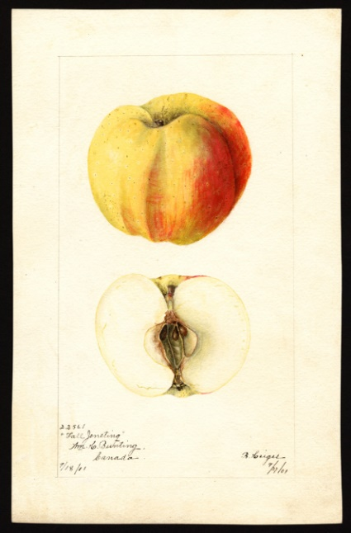
One of the most unusually shaped apples. The tree produces beautiful orange, red, and yellow apples that have distinct ridges. The apple was popular at one time and is described in a variety of books and pamphlets from the 1800’s into the early 1900’s.

The book “The Apples of New York”, by S.A.Beach, volume 2, 1903, describes the Fall Jenetting as “very good for culinary uses and acceptable for dessert; is not a good keeper.”

Another book stated that the Fall Jeneting “is a variety that cannot possibly be beaten in the way of canning apples.”

Dickinson: 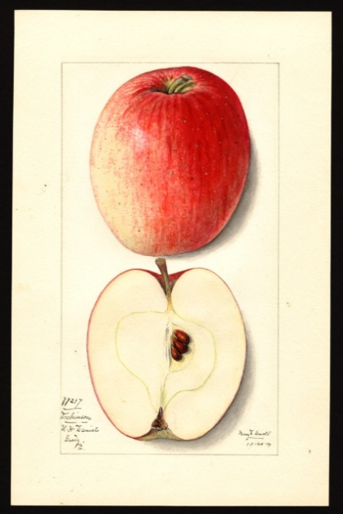
…Very productive. Fruit resembles Yellow Bellflower in shape, but the color is red. It is of good size and attractive enough in appearance to make a good market apple, but it is not above second rate in quality.
Historical. Grown from seed of the Yellow Bellflower by Sarah Dickinson, Westchester, Pennsylvania……..
Fruit medium to large, somewhat variable in size. Form oblong-conic…Skin smooth, light yellow or green, blushed and mottled with bright red, striped with darker red, sprinkled with inconspicuous, small green and whitish dots. Prevailing effect red with well-colored fruit…
Flesh yellowish, juicy to very juicy, moderately fine-grained, slightly aromatic, subacid, moderately firm, tender, fair to good. Season November to April.
Known as a good keeper.

Nero: 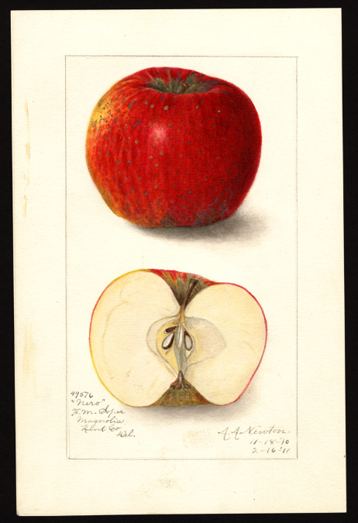
Rediscovered 2014 at Stepteo Butte State Park. Deeply red skin, round, built like a Jonathan. Small apple but tasty.
Arkansas Beauty: 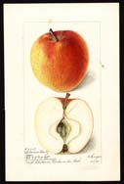
Rediscovered 2016 med-large fruit has carmine strokes over cardinal red, nearly white flesh is fairly sweet, firm; vigorous, open crowned, very good flavor
Shackleford: 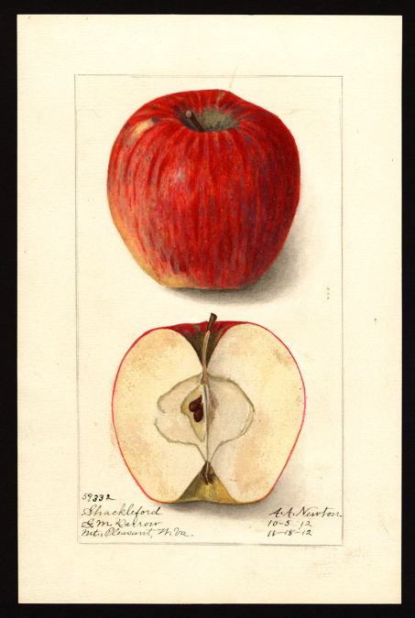
Rediscovered in 2017 in Spokane County, widely adaptable, for Lee Calhoun includes it among his descriptions of Southern apples and re-discovered it in Whitman County in 2017. Medium to large round-oblong, deeply red with light “bloom” (yeast coating), thick & tough skin. Dave considers this the best tasting of his rediscoveries.

McAfee: 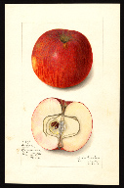
Rediscovered in 2017 near Steptoe Butte. Medium to large, Yellowish green splashed and striped red flushing to crimson, flesh yellowish white, described as good to very good for dessert or market use. Ripens late Oct/early Nov

Regmalard: 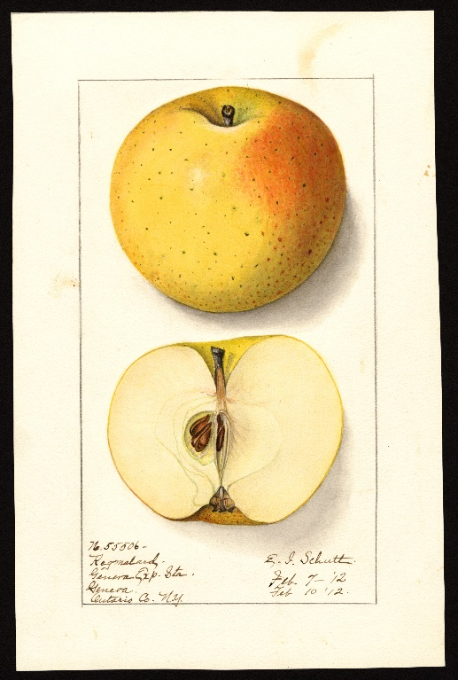
Found in Latah County, ID, in 2018. Origin is unknown but was known as far back as 1892 in New Jersey and Pennsylvania. Large apple, skin deep yellow with a small patch of light reddish blush. Dots conspicuous. Very good flavor. Keeps well
Excelsior: 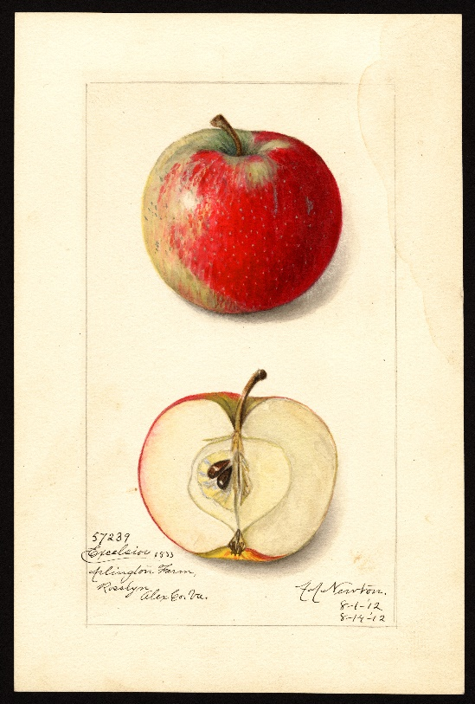
Rediscovered in Latah County. A seedling of Wealthy. Considered a crab but very large for a crab or small for an apple. Taste described as juicy, tender, pleasant subacid, agreeable for dessert, good to very good for kitchen or market use. Historically significant as it is a seedling of the first bred apple tree in America. Ripe early Sept.

2019
Sary Sinap: 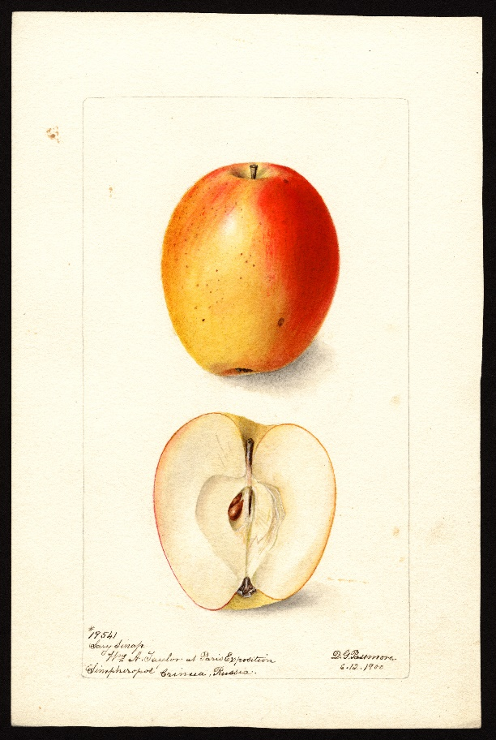
This is an ancient variety from Turkey. It is medium in size yellow skin blushed with pink or red wash. The apple is an early apple where it was found in Idaho and has remarkable keeping properties for an early apple. At one time Nick Botner of Oregon and the USDA in New York, and Washington State University once had the apple in its inventory but the apple has not been seen in the US in years.

Givens: (also known as Arkansas Baptist) 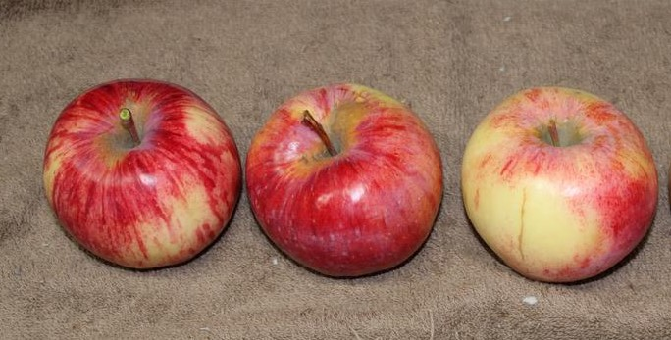Origins of this apple trace to Arkansas in the mid 1880’s. Its skin is greenish to bright yellow and nearly covered with dark red and dark red stripes. It is said to be good to very good quality for market use
Colman: (Collman) 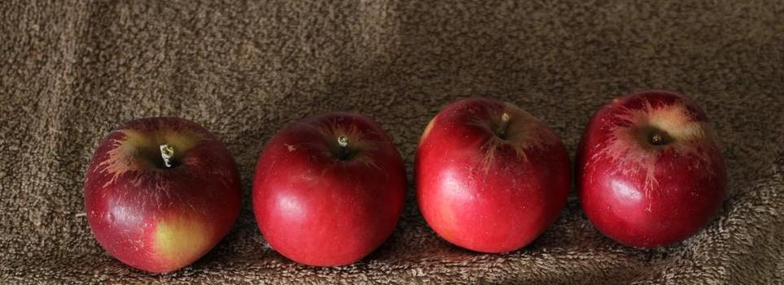 Was introduced in 1884 by a man in Ohio. It is described as large, round, yellow, with red stripes and splashes. The flavor is described as very good quality for dessert or market use.

Claribel: 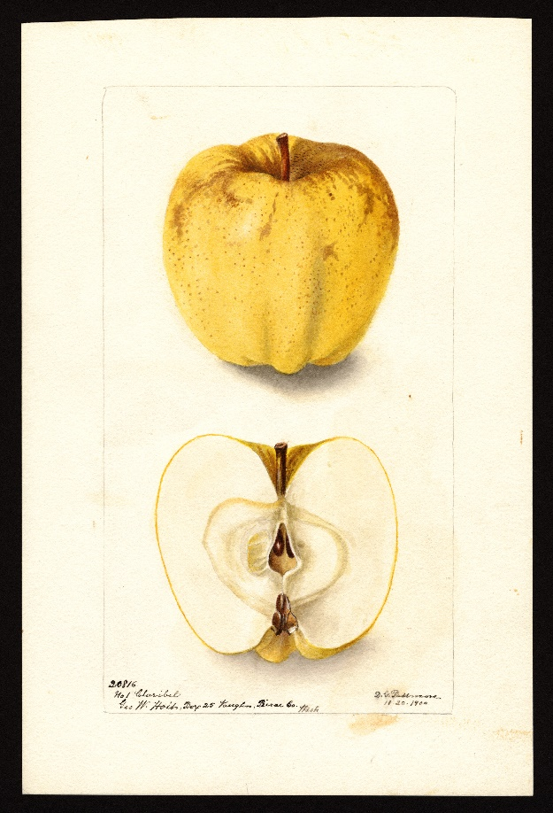
This apple first noticed when a man from Pierce County, WA, sent the apple to the USDA for a watercolor painting. It is large, yellow with dots, and good spritely sub-acid flavor.
Butter Sweet (of Pennsylvania): 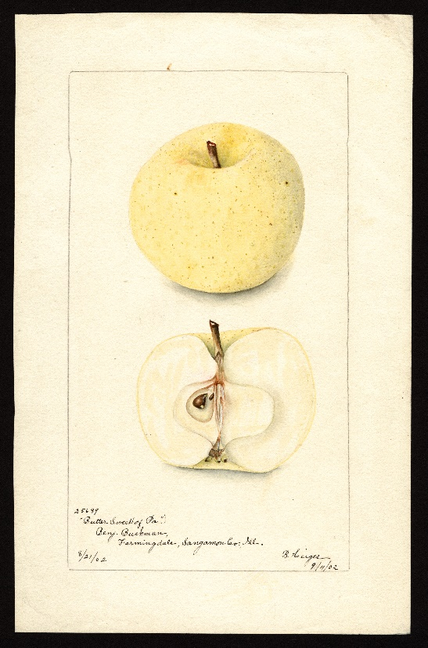
The origin of this tree is unknown but was grown in the trial orchard of Benjamin Buckman in Illinois in 1901. The skin is light “butter yellow” with dark colored dots. Medium in size.

Streaked Pippin: 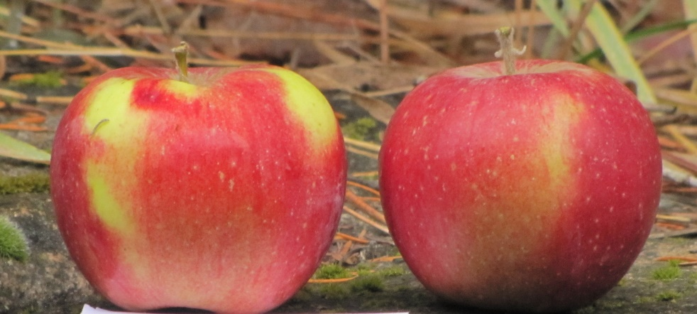
This apple was first recorded in 1869 but may have originated as early as 1744, in New York. It is a large apple, pale yellow to greenish, blushed orange-red and dark red stripes. It is described as good to very good quality. Found near Waitsburg
Milalyfi: 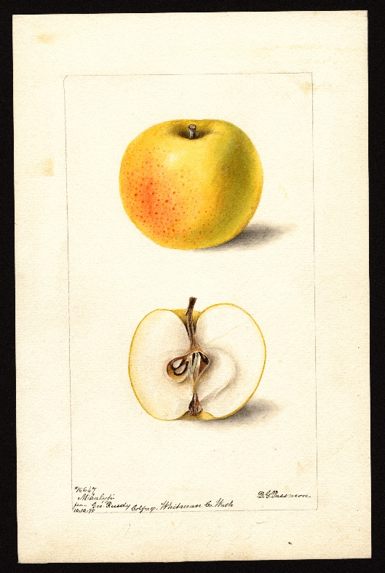
This apple is a Hungarian variety that was one of 20 Hungarian apple varieties sent to the Washington State Experiment Station in the late 1800’s. George Ruedy, a nurseryman in nearby Colfax, also grew some of the trees and likely sold the tree that was found about 20 miles from Colfax and five miles from the Washington State Experiment station in Pullman. In 1898 Ruedy submitted the apple to the USDA where the apple was painted in watercolors in the late 1800s. The apple is described as yellow with a red blush, medium in size, and “good for kitchen use.”

Not lost…. But great apples
Palouse: 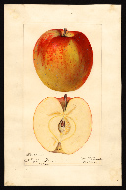
The Palouse has never been extinct and is known as the only apple discovered in eastern Washington that went on to become very popular back east. Was sold in railroad car lots at one time. Good size, good keeping ability, and very good taste.

McMahon White: 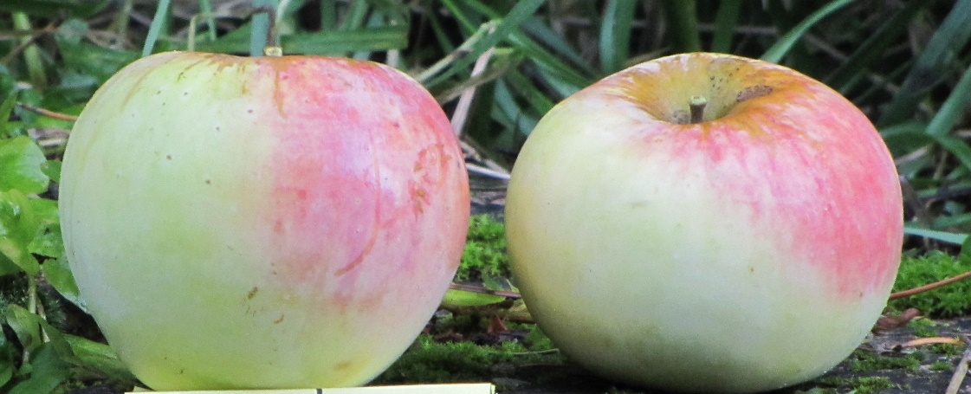
This is a popular old variety that has never been extinct. Many nurseries in the northwest carried this apple and it is easy to see why. Beautiful coloring and very good taste.

