Bark Graft
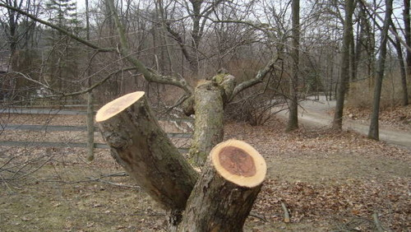  When topworking younger trees the cleft graft is usually used. However, with larger diameter scaffold limbs of more than 3 inches a bark graft is used. | The cut is made perpendicular to the direction of the limb to be grafted. In picture on left note that a large nurse limb has been left to nourish the tree during the first year of the development of the grafted scions. Note that on big limbs or trunks you insert a scion about every 3 or 4 inches around the circumference. Next year the nurse limb will likely be converted over to the new variety too. | 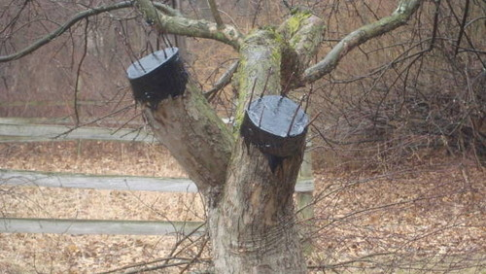  After the scions are inserted and secured all exposed surfaces, including the tops of the scions are covered to prevent desiccation and promote healing.

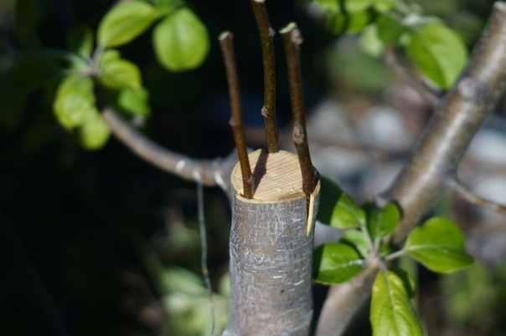 | On the smaller diameter truck to the left only three scions are inserted. Although difficult to see, both the one on the left and the one on right have a single slit into which the scions are inserted. The one on the left probably will not be nailed, just wrapped tightly with tape. | 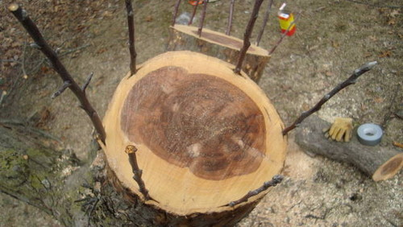  One slit for each scion and nails were probably used on the large diameter scaffold branch above.

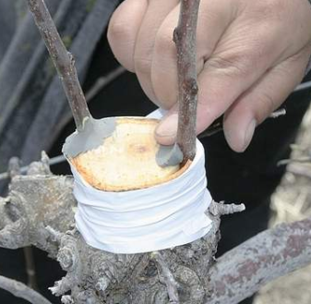  Bark grafting was used on the tree above because it was too large and also a little gnarled for cleft grafting. | To the left is an example of the use of bark grafting to change over a central leader tree that is only 4 or 5 years old. Clay is being used to fill gaps around the scions to reduce the chances of the scions drying at the union at the top of the central leader. It will then be covered with tree seal. The new tree could have a central leader structure (one of the scions would later be removed) or a “V” structure which is common in high density plantings. Note that lower limbs have been left as nurse limbs | 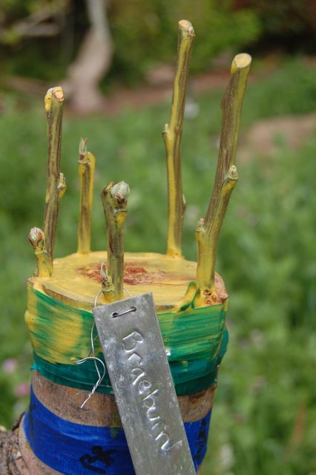

Single Slit Per Scion Method
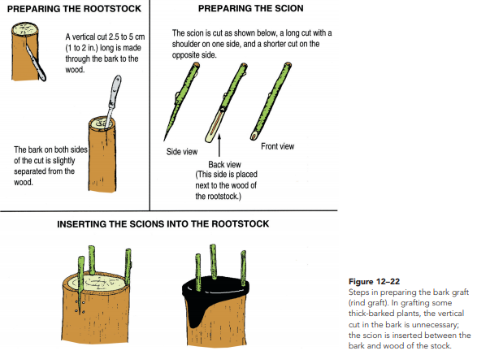

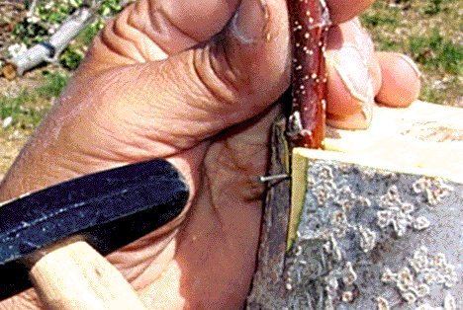  The cut in the outside of the bark just to the right of the brad was made to even out the surface of the bark so that when it is wrapped with tape the tape can force all of the bark to lie tight against the inserted scion. The nails hold the scion tight but you also want the bark to be held tightly as well. | Note how small the hammer is. Using the small tack hammer provides greater control so the grafter can avoid damage to the fragile scion wood.  On the example to the right of a fruit tree all of the major scaffold limbs have been bark grafted, with only a few small braches left as nurse limbs. | 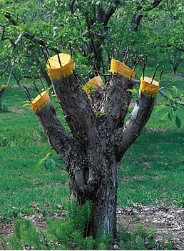

The single slit bark graft is a little faster to execute than the double slit version, but requires that the bark lifts from the cambium layer (warmer temperatures with buds starting the break). After the single slit is made the knife is used to create an opening into which the scion will be slid. Small brads are used to close the bark tightly around the inserted scion. Often this will be tightly wrapped with tape before coating with tree sealant.
Two Slits Per Scion
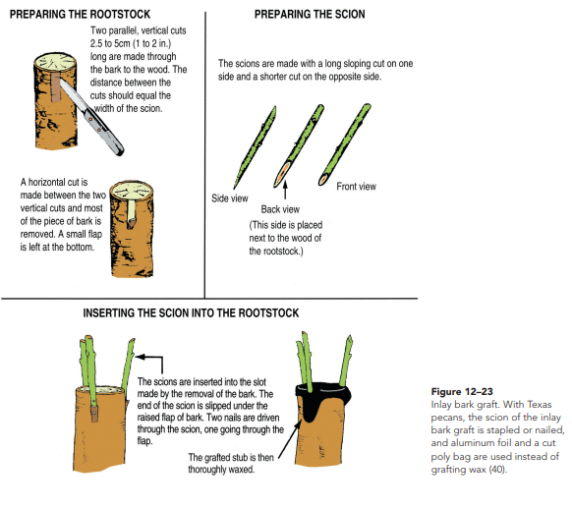
When two slits the width of the scion are used there are variations in how the scion is held in place. One option is to nail them in place with small brads as seen above. In the example above part of the flap is left and forms the bottom of the pocket for the scion. Another option is to cut off the flap and square off the end of the scion to fit snug against the bottom of the rectangular pocket created. This is then nailed in place. As seen in the examples below to the left, some grafters leave the whole flap on and then run strong tape around the limb to hold the scions tightly in place. In all cases the graft and the tips of the scion are covered thoroughly with a tree sealant to prevent discatation.
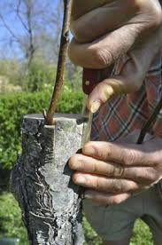 | 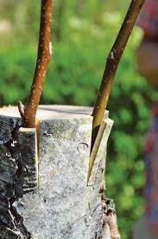 | 