CHIP BUDDING PICTURES AND DIAGRAMS
Picture #1 |  | Picture #2
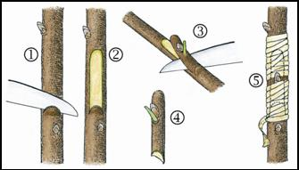  Above is a classic diagram of the steps involved in making a chip bud. However the wrapping could be improved by crisscrossing around the petiole. When you crisscross, you cover all the sides where cuts have exposed the plant tissue and minimize letting the chip dry out |  | 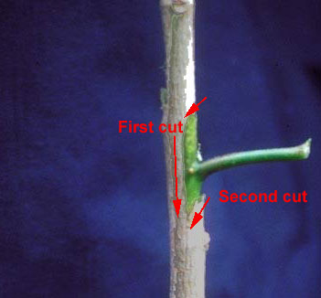 Understock: Doesn’t make any difference which order the cuts are made. Bottom cut is 22-45 deg.
Picture #3  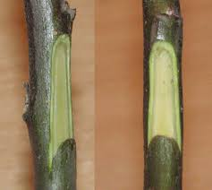  Side view (left) and front view (right) of cleft cut into the understock to receive the chip bud. The bright green band around the edge of the cut is the cambium layer. |  | Picture #4  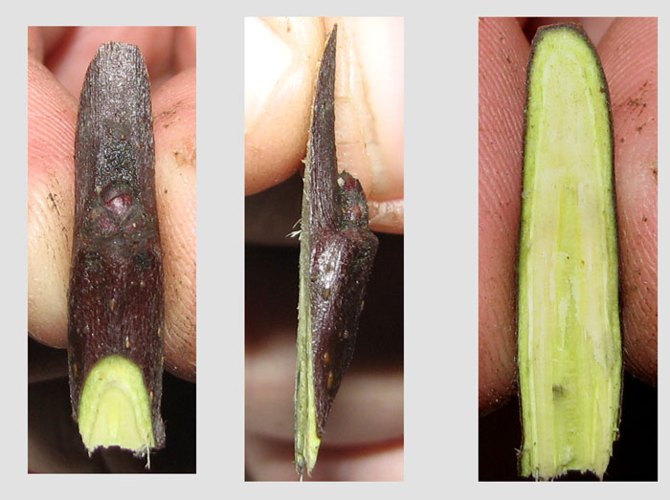  Front view of chip (left), side view (center), and back view of chip (right). In this case it is dormant, indicating spring chip budding.
Picture #5  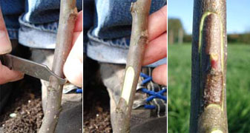  The frame on the right, above, is a pretty good fit with the cambium of the understock exposed on right and left boundaries, leaving an ideal gap size for a callous bridge to form. Compare to the slightly larger gap zone in Picture #6. |  | Picture #6  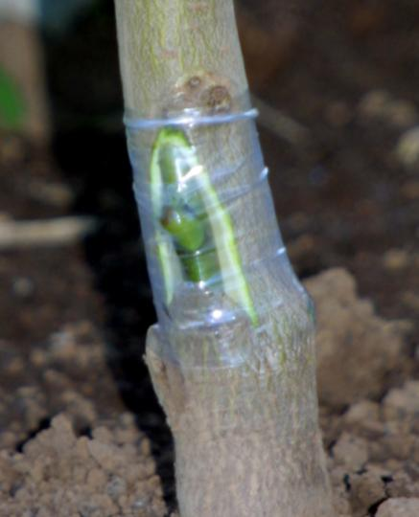  Wrapped chip bud (from p. 520 in Hartmann text). (The gray color along the left and right side of the chip bud is part of the heartwood of the understock.
Picture #7  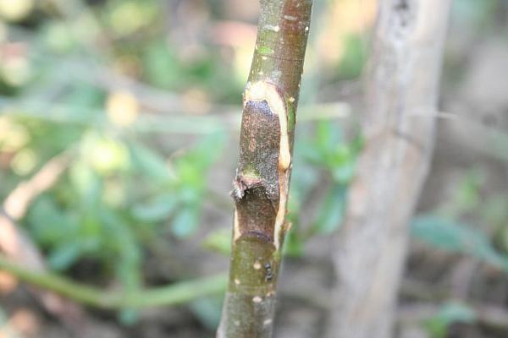  Note the callous bridge (dried white substance) around the chip. The leaf petiole has dried and fallen off, leaving a live bud to form a shoot the following spring. In the spring a slanting cut (downward away from bud) will allow the new shoot to assert apical dominance and grow upward without sending out side shoots or creating flower buds during the first year. |  |  | Picture #8  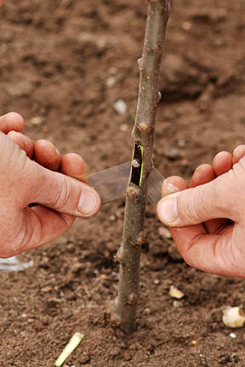  Compare the size of the exposed area around the chip bud (it is very small) with picture #6 on the previous page, which is from the Hartmann text which is a little larger in comparison. The take-away is that you have latitude in sizing the exposed area as long as you do not overlap the chip onto the understock bark which would prevent the union of the two cambiums (however I have a preference for minimizing the size of the gap – I prefer #8 over #6)

Picture #9  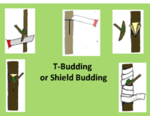  T-budding and Chip budding are the most common methods of field propagation of fruit trees. |  | Picture #10  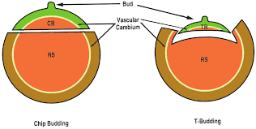  Above on the left we see that in chip budding we have close alignment between the cambium of the chip bud and the cleft created in the understock. This makes the formation of the callus bridge rapid and strong. This is not the case in T-budding (to the right).  T-budding is easier to learn and easier to execute, but is being replaced by chip budding because chip budding has a higher success (“take”) rate, results in stronger and straighter unions, produces a tree that is more cold hardy, has greater uniformity and growth from the bud, and can be executed over a longer season (bark does not need to “slip” for chip budding).

