Cleft Graft
This version has additional notes in blue text.
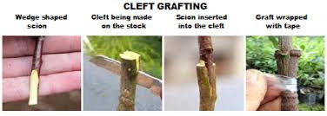  At its most basic level cleft graft can be used where the shoot and the scion are the same size. Note that the tapered scion is equal on both sides (vs. slightly tapered for a typical two-scion cleft graft). | 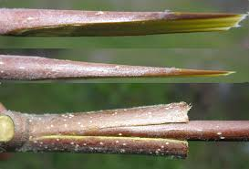

However, the most widely used version of cleft grafting is where two scions are used on a large branch (up to 3 inches in diameter) involving the insertion of two scions of equal size on the outsides of the branch.

Note: It is the alignment of the cambium layers of the scion and the understock that makes any graft work. The cambium layer is bright green and is in between the bark and woody center of both a pencil-size scion and the larger understock limb being grafted to.

In the diagram below (snipped from the bigger diagram further on down) they have tried to emphasize the above point that when you have a large understock (an inch to three inches) the bark is thinker than on a scion which is only a year old and pencil-sized. It is hard to see but what they tried to show you was that you align the cambium of each, not the outside of the bark. Thus, the scion is pushed in beyond the outside of the bark on the understock so that the two cambium layers align (the outside of the bark of both scion and understock will NOT be aligned when you do this).

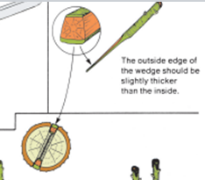

Note: In the picture below you see a special tool being used. I see them in pictures, but haven’t seen one in real life. I use a grafting knife with understock up to about one inch and a butcher knife for up to three inches. I use a flat bladed screw driver to pry the split understock open to insert the scion after it has been cut with a knife.
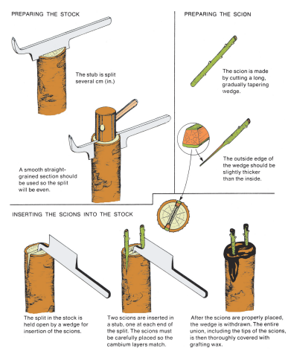
Notes:  - It is the pressure of the split limb to close up the cleft created by splitting that holds the scions in place.  - All exposed surfaces (including the tops of the scions) are coated to prevent desiccation and promote healing. | 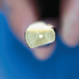  Note taper of the scion. |  | 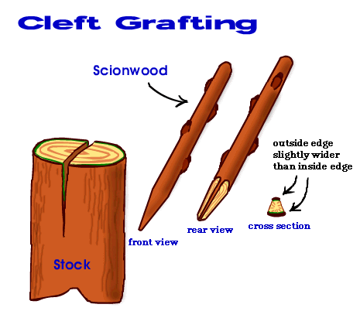 |  |  | Wide side of taper goes to outside of cleft and narrower side of the scion goes toward the center of the cleft.
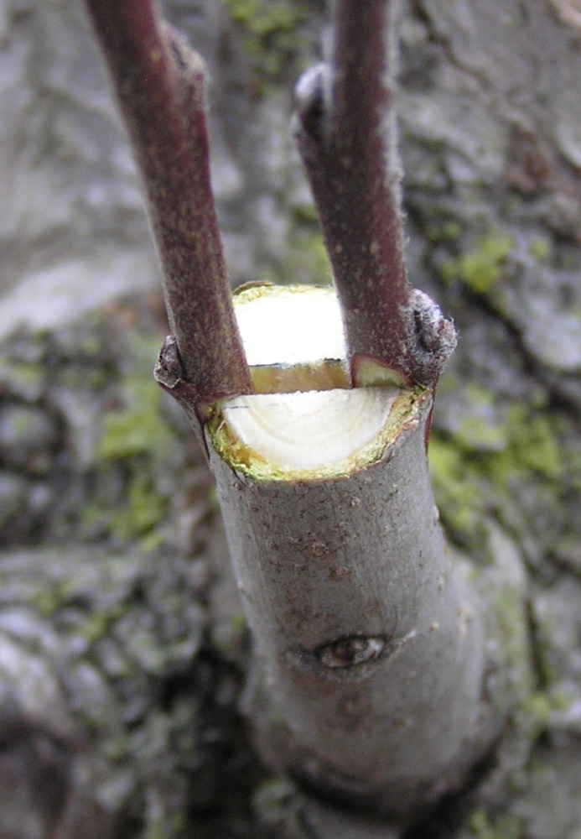  On larger branches there is enough pressure by the limb’s attempt to close back up to hold the scions in place. This will be covered to prevent it from drying out. End of scion is also covered.  Note: In the picture above you see an opening between the two scions. You don’t want the green goop (Doc Farwell’s Seal and Heal) that you will be covering the wound with to get down that hole. You take out a little of the green Play-Doh and seal that hole (just seal it, don’t stuff a whole bunch down to fill it) before covering it with Doc Farwell’s green goop. You also use Doc Farwell’s on the tip of any cut scion to seal in the moisture so it doesn’t dry out. |  |  |  |  | 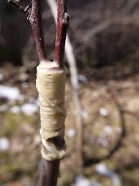  On smaller branches twine, rubber bands, or tape will be used to force the two sides of the cleft back together to exert pressure to hold the scions in place.
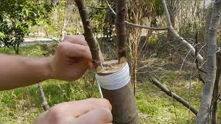  Limb is being wrapped with tape in preparation for coating with wax or other protective coating.  Note: After using the rubber band to provide pressure to close the cleft (see picture above to the right) you can cover the complete side like is being done above with white tape with Parafilm, It is in your packet. It is 1 inch wide and stretcheee and semi self-adhering when stretched. Cut a piece about 6 inches long. Stretch it a little bit with each spiraling turn around the understock,  To the right is a before and after comparison showing scions first being inserted in a new cleft graft and the growth after three to four years. |  |  |  | 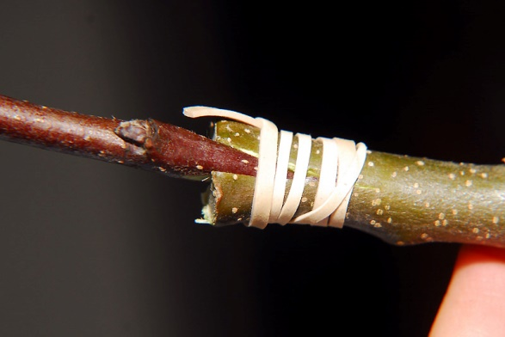  A single scion can be used on a small side branch with a cleft graft. Note the use of a budding rubber to provide nice tight contact between the scion and the sides of the cleft.  