Re-Discovered Apples
The apples described below are available to order in 2024 as scions (mailed) or as trees to be picked up locally near Spokane and Pullman. WA.

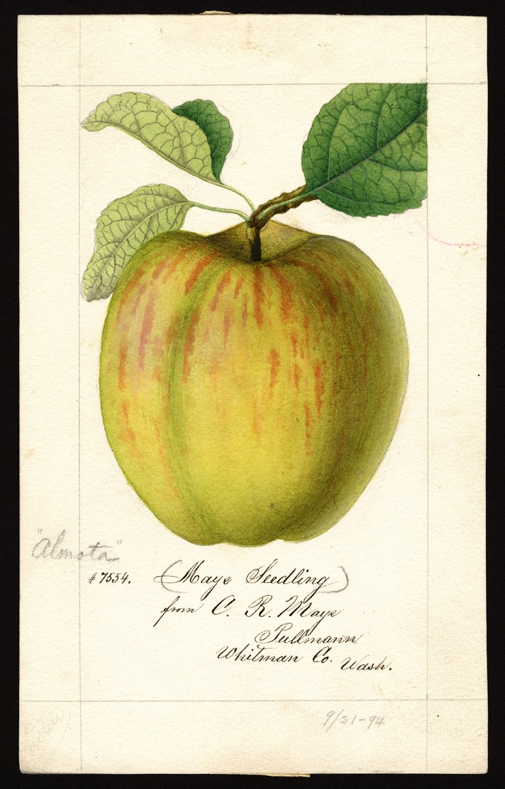
Almota
Almota was a seedling apple discovered by Charles Moys in Whitman County, Washington, in the heart of the Inland Empire. The tree was six to eight years old in 1894. USDA artist
William Henry Prestele painted a watercolor of the apple in 1894 that incorrectly states Moys’ surname as “Maye” and gives the apple the name “Maye Seedling”. The painting also listed the name Almota as an alternative name. The apple is described as very large with pale yellowish skin, washed and striped with red. It ripens in September in the northwest. It is good quality for dessert. Not a good keeper.

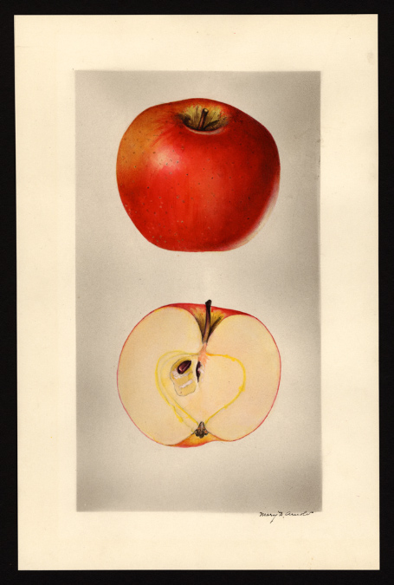
Arkansas Beauty
The book, Old Southern Apples notes that the Arkansas Beauty was extinct and that it was introduced in 1886. Stark Bros’ Nursery carried the apple in their catalogs in the early 1900’s.
The apple was described in The Apples of New York, vol 1:
“The Arkansas Beauty is of Arkansas origin. It is above medium in size. The flesh slightly tinged with yellow, … moderately crisp, tender, juicy, mild subacid, taste is good.”
This apple actually colors better in eastern Washington than its native Arkansas. The apple was rediscovered in 2016 in Whitman County, WA.

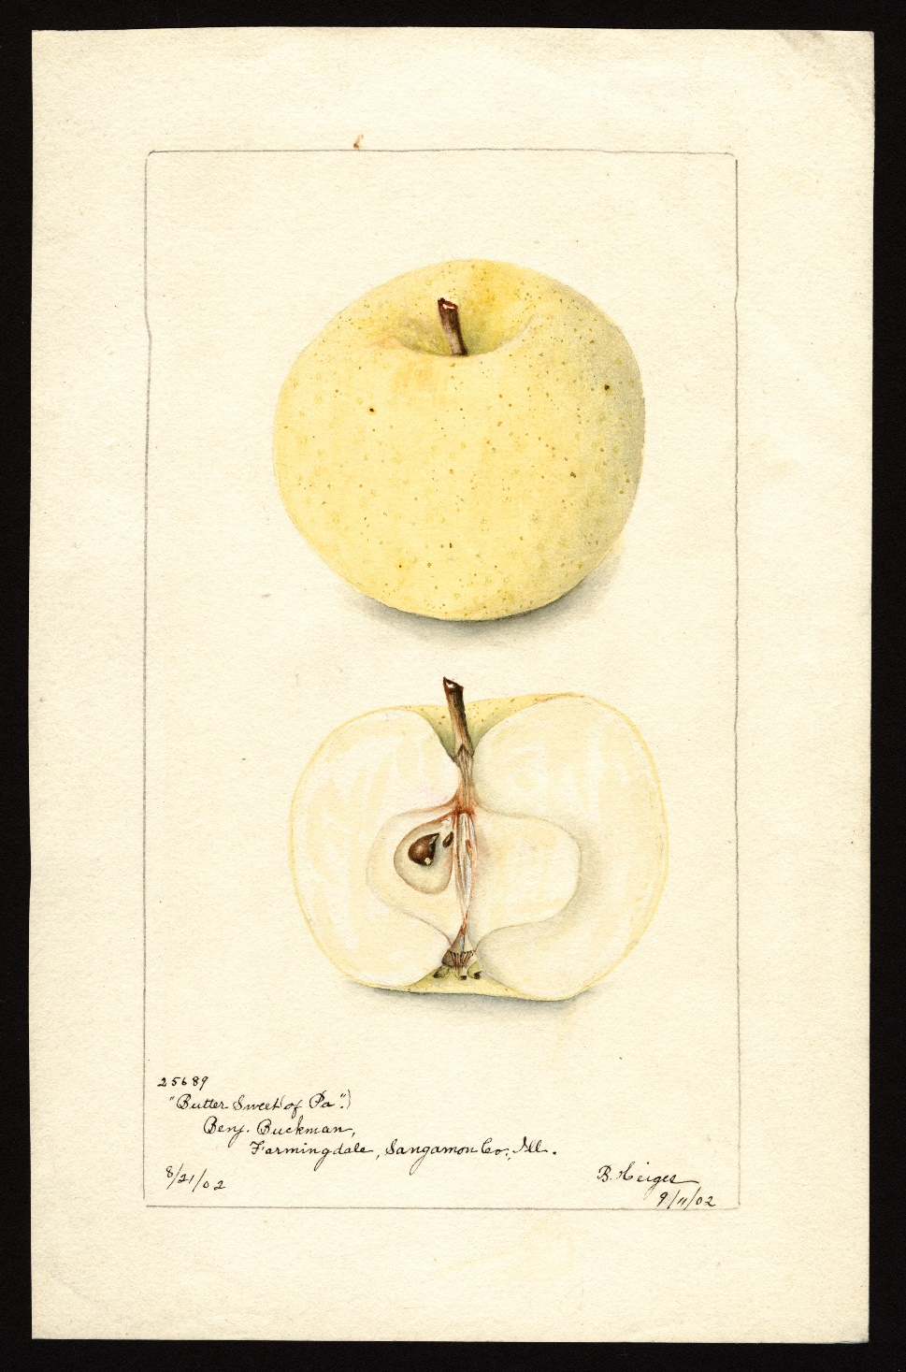
Butter Sweet (of Pennsylvania):

Butter Sweet (of Pennsylvania): The origin of this tree is unknown but was grown in the trial orchard of Benjamin Buckman in Illinois in 1901. The skin is light “butter yellow” with dark colored dots. Small to medium size. Very pleasant, sweet taste.

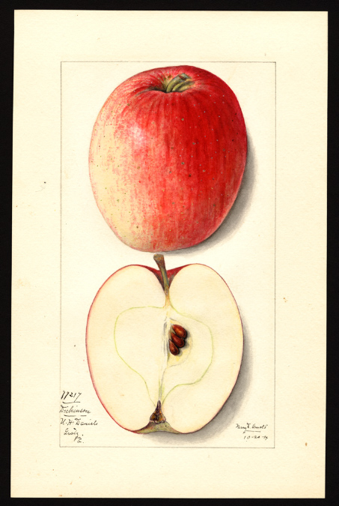
Dickinson
Below is a description from The Apples of New York, vol 2:
…Very productive. Fruit resembles Yellow Bellflower in shape, but the color is red. It is of good size and attractive enough in appearance to make a good market apple, but it is not above second rate in quality.
Historical. Grown from seed of the Yellow Bellflower by Sarah Dickinson, Westchester, Pennsylvania……..
Fruit medium to large, somewhat variable in size. Form oblong-conic…Skin smooth, light yellow or green, blushed and mottled with bright red, striped with darker red, sprinkled with inconspicuous, small green and whitish dots. Prevailing effect red with well-colored fruit…
Flesh yellowish, juicy to very juicy, moderately fine-grained, slightly aromatic, subacid, moderately firm, tender, fair to good. Season November to April. Known as a good keeper. This apple was re-discovered in Whitman County, WA, in 2016.

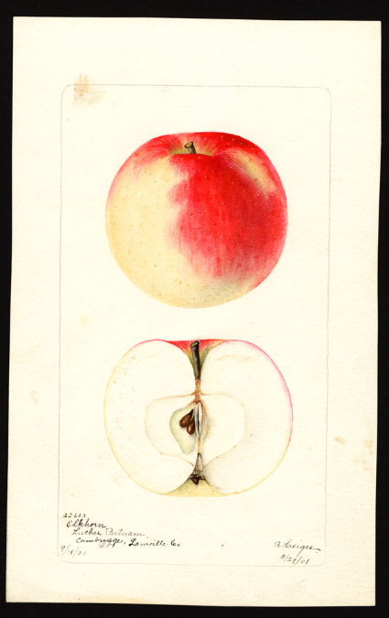
Elkhorn
The fruit is described as “large to very large, red with red stripes on distinct and lighter bases.” The apple is said to have very good quality. Casimir Holeski, a nursery owner and fruit explorer in Bonners Ferry, Idaho, has been actively looking for old apple varieties near his home in northern Idaho. He met with Shaun Shepherd of Temperate Orchard Conservancy. In early 2020 we learned the apple had been positively identified as the lost Elkhorn!

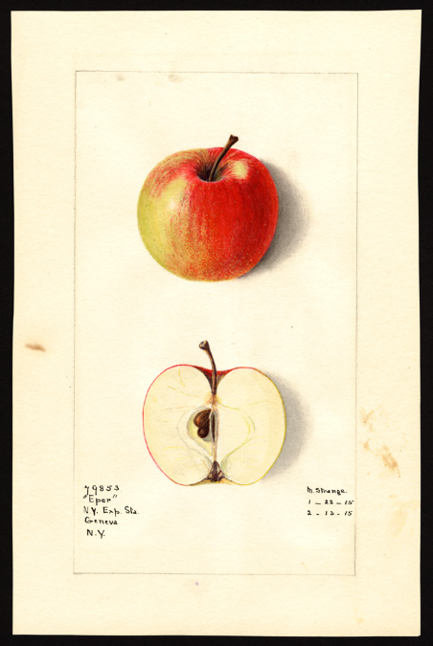
Eper

A Hungarian apple tested by WSU and a Colfax, WA, nursery in the late 1800’s. The tree was found approximately 20 miles north of Colfax. The apple is small to medium in size and mostly red in color. Apple ripens in early September and has a very good sweet/tart taste.

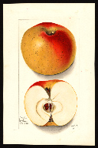
Ewalt
The Ewalt originated at the farm of John Ewalt near Bedford, Pennsylvania, sometime before 1800. The apple is described as a large yellow apple with a crimson flush. The flesh is described as firm, juicy, with good to very good quality. A good keeper apple, the Ewalt can last in storage until April or longer. This apple was re-discovered near Hauser Lake, ID, in 2017.

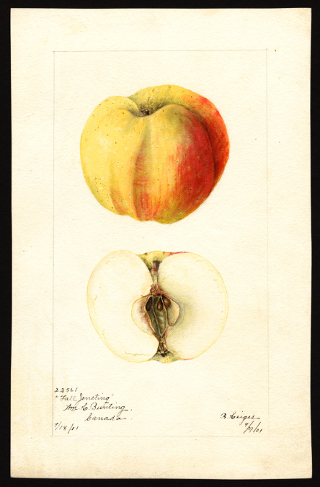
Fall Jeneting
One of the most unusually shaped apples ever. The tree produces beautiful orange, red, and yellow apples that have distinct ridges. The apple was popular at one time and is described in a variety of books and pamphlets from the 1800’s into the early 1900’s.

The book “The Apples of New York”, by S.A.Beach, volume 2, 1903, describes the Fall Jenetting as “very good for culinary uses and acceptable for dessert; is not a good keeper.”

The twenty-fifth annual report of the Fruit Growers Association of Ontario (Canada) sessional papers (37) 1894, stated that the Fall Jeneting “is a variety that cannot possibly be beaten in the way of canning apples.”

The apple is stunning in appearance, good tasting, but as a fall apple, ripening before the end of September, will not last in your refrigerator as long as winter varieties.

This apple was re-discovered in Maine in 2013. A second Fall Jeneting was found in Whitman County, WA, in 2014.

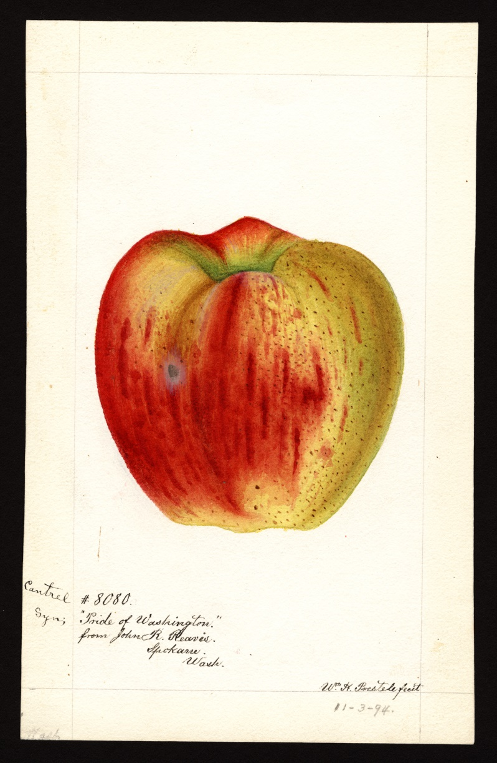
Frazier’s Prolific, aka Cantrel or Pride of Washington
Cantrell (Cantrel) Frazier planted one of the first commercial orchards in Walla Walla County. Walla Walla historian W. D. Lyman wrote about Frazier in 1918, saying one of his seedlings grew into a mammoth tree that was reputed to be the largest in the state - more than 7 feet, 7 inches in circumference around the base with a spread of 57 feet and height of 42 feet. Frazier and his tree gained fame when it yielded a crop of over 126 boxes of apples in 1907. The tree was commonly called Frazier’s prolific apple tree. Although the original tree died in the 1980’s it was cloned shortly before perishing. A clone was planted near Fort Walla Walla Mueum and still produces big crops of apples. This apple is not considered a desert apple. Its best use is in the kitchen for pies and other treats.

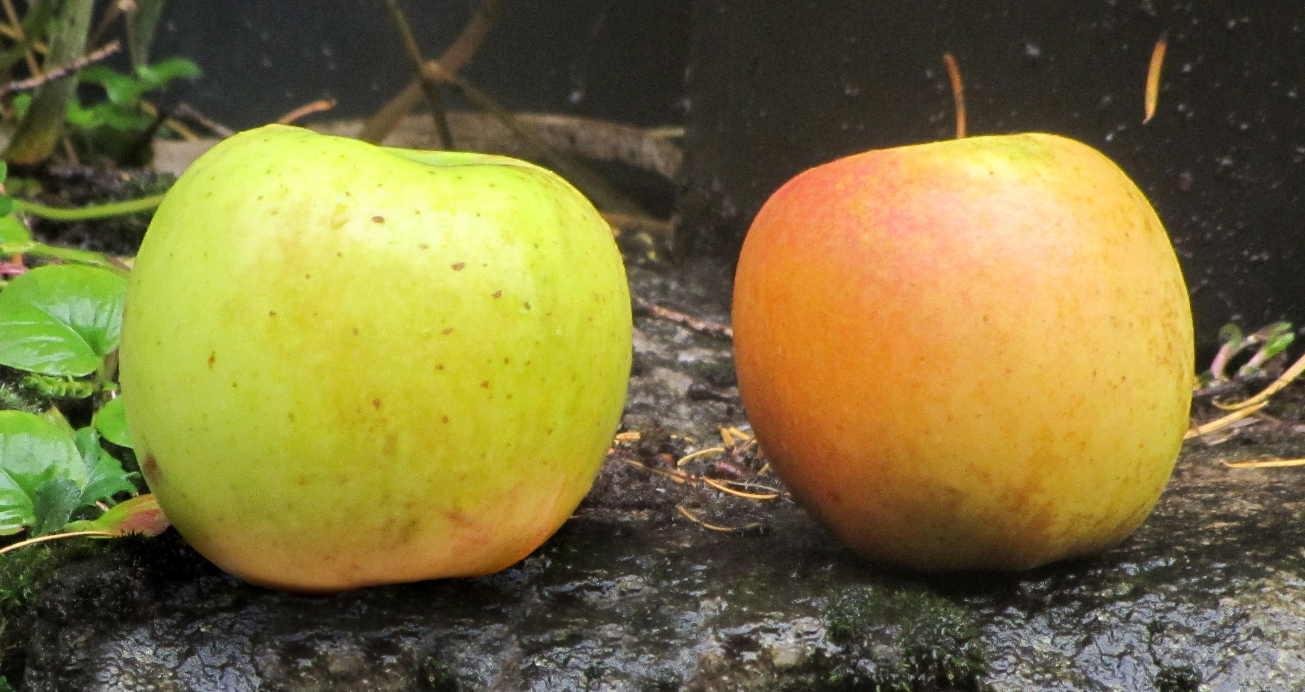

Gamble Gold

A medium sized apple found in the homestead orchard of Christian Gamble. Gamble took up his homestead near Moscow, Idaho, in 1880. The apple is medium in size and is ripe in October. Very good sweet/tart taste and gold skin when ripe. The apple has been given the provisional name "Gamble Gold" until the true name of the apple can be determined.

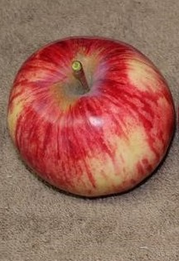
Givens
Givens: (also known as Arkansas Baptist) Origins of this apple trace to Arkansas in the mid 1880’s. Its skin is greenish to bright yellow and nearly covered with dark red and dark red stripes. It is said to be good to very good quality.

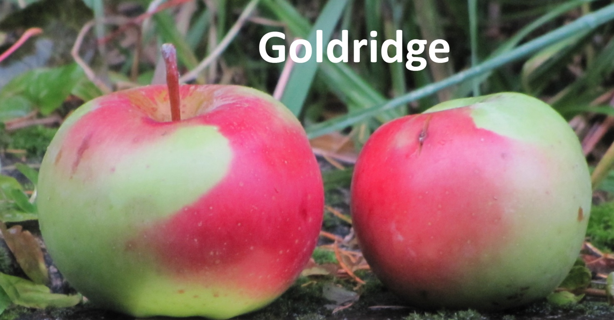
Gold Ridge
Gold Ridge (aka Goldridge) was an apple from the breeding program of Luther Burbank in 1912. The apple is medium to large in size, yellowish green blushed crimson. The apple is described as excellent to best in quality. The tree is also “not subject to mildew or scab.”

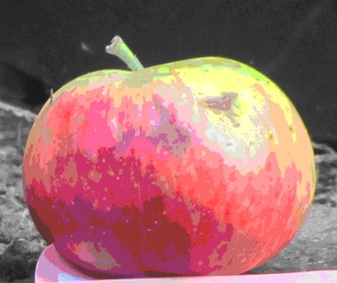
Iowa Flat
According to Dan Bussey, Iowa Flat most likely originated in Iowa and was sold by a nursery in Nebraska not far from the Iowa border. Specimens were sent to the USDA in 1896. The apple is described as large but very oblate in shape. The skin is yellow or greenish yellow covered with red blush and red streaks on the sun side of the apple. The apple is very good for fresh eating.
Iowa Flat was found near Orchard Avenue in Moscow, Idaho. The tree was also in Benjamin Buckman’s experimental orchard in 1901.

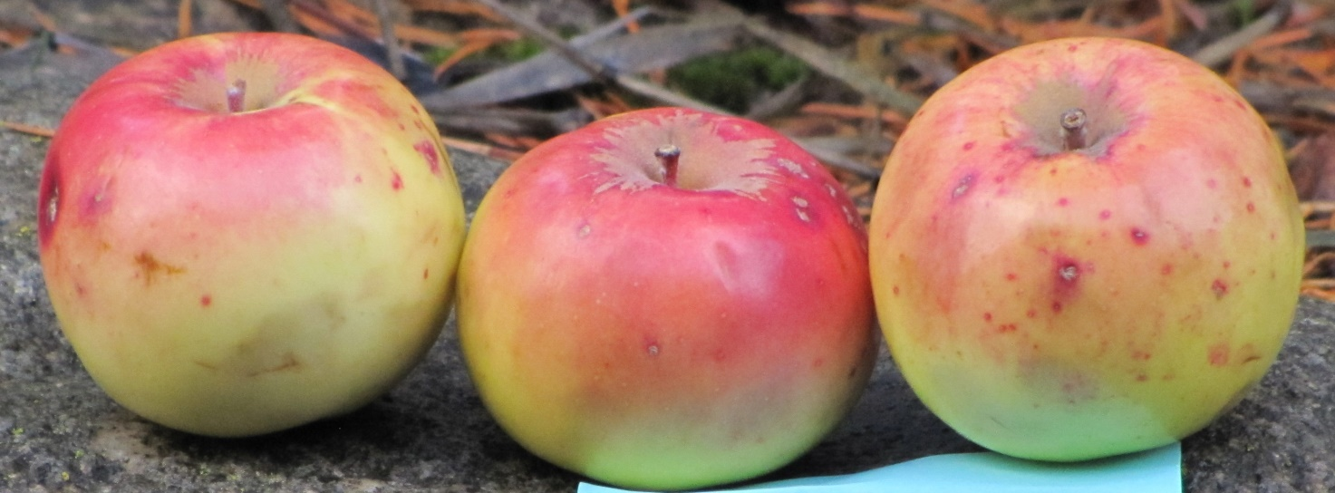
Kittageskee
Probably originated with the Cherokee Indians in North Carolina, introduced in 1851. It was sent to France by P. J. Berckmans Nursery, Augusta, Georgia, in 1860. It was sold in Europe until at least 1905. The apple has yellow skin flushed with bronze. It is small to medium in size, the flesh is nearly sweet and aromatic. A very good winter apple. Considered extinct when it was re-discovered near Boise, ID, in 2017.

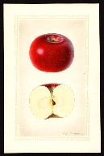
Nero
Note: A quite small apple. Originated on a farm in New Jersey in 1879. Popular apple in New York in the early 1900’s. Medium to above medium in size. Roundish and bright red. Flesh crisp, juicy, subacid with sweet taste. Late in season.
Considered extinct when it was re-discovered in Whitman County, WA, in 2015.

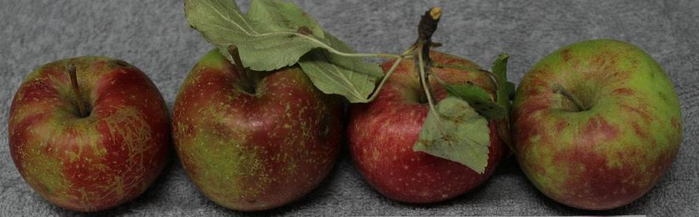

Polly Bemis

Polly Bemis is a folk hero from the early history of Idaho. Bemis was born on September 11, 1853 in China, and forcibly taken to the Idaho Territory at the age of 19. Her story has been the subject of books and film and her cabin on the upper Salmon River, in Idaho, was placed on the National Register of Historic Places in 1988. In 2020, E.J. Brandt of the Lost Apple Project learned there were still apple trees at the Bemis Ranch on the Salmon River. Brandt reached the ranch, only accessible by boat or helicopter, for the first time in September of 2020. Apples were subsequently picked from several trees at the ranch and submitted to experts for identification. Some trees were identified but two trees of the same variety were not. Leaves were then collected and a DNA test at Washington State University revealed the apple was unknown. When neither examination and DNA tests could determine the true identity of the apple, TOC, WSU, and the LAP agreed the apple should be given the provisional name "Polly Bemis".

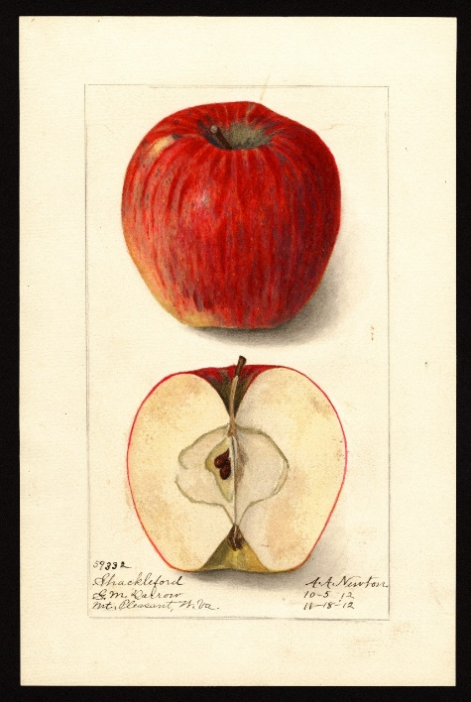
Shackleford
Apple expert Lee Calhoun wrote that the Shackleford is “medium to large, roundish or roundish oblong; skin thick, tough, waxy, smooth, pale-greenish yellow washed with red and mottled and striped with carmine….crisp, juicy, mild sub-acid. Ripe December – May. In a nursery catalog from 1912, the Shackleford was described as “large, well colored, purplish red in the sun, with a delicate bloom; mild sub-acid, aromatic. Considered extinct when it was re-discovered in Whitman County, WA, in 2017. Apple researcher David Benscoter considers the Shackleford one of the best tasting of the recent re-discoveries.

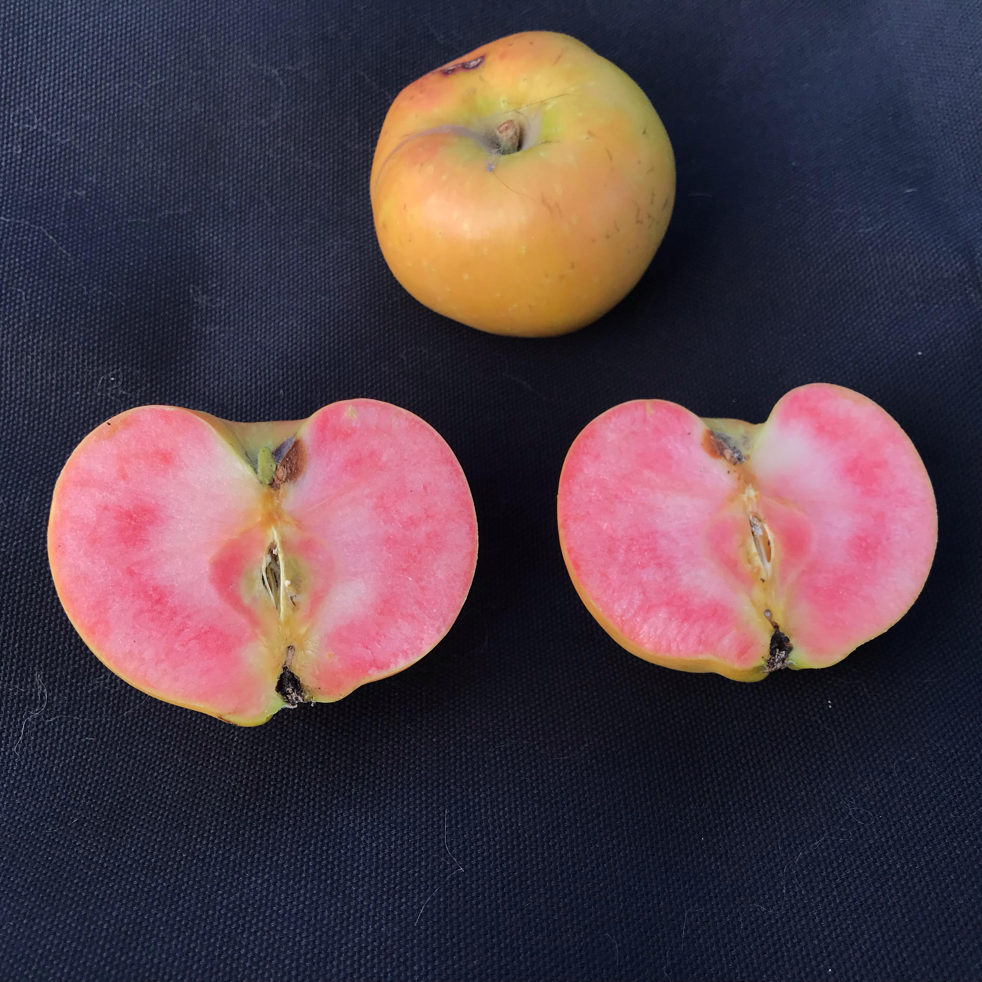
Surprise #1
Surprise #1 was found near Dayton, Washington, in 2017. The apple is small to medium in size and yellow apple. It isn't until you bite into the apple that you realize this is no ordinary apple. The apple is unique by way of its “surprising” pink flesh. Harvested in late October, the apple has a very good sweet/tart flavor.

According to Dan Bussey, the apple was discovered in Colorado prior to 1898. A Ritz Nursery catalog from nearby Walla Walla indicates the apple was available in southeastern Washington in 1879.

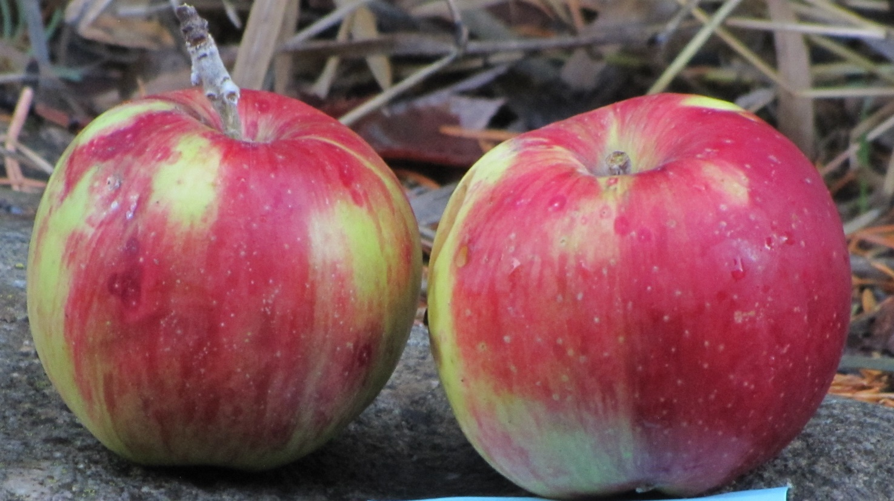
Streaked Pippin
The Streaked Pippin was first recorded in 1869 in New York but may date back to 1744. It is a large apple, pale yellow or greenish covered by an orange-red blush and distinct deep red stripes. The flavor, as described in apple books, is good to very good. The tree was found at the site of an old homestead near Waitsburg, WA.

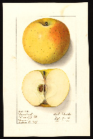
Regmalard
The Regmalard, also known as Reinette de Regmalard, was known to have been grown in New York, New Jersey, and Pennsylvania in the late 1800’s and in Illinois and New York in the early 20th century. The apple is large, yellow, with a small blush of red. It ripens late and is considered a good keeper. A watercolor of the apple was painted in 1912 by the US Department of Agriculture and is available to view on its website. LAP volunteer E.J. Brandt found this apple growing in a forgotten orchard near the town of Troy, ID.

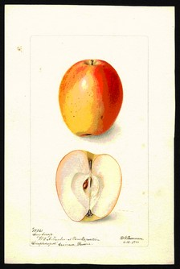
Sary Sinap
This is an ancient variety from Turkey. It is medium in size yellow skin blushed with pink or red wash. The apple is an early apple where it was found in Idaho and has remarkable keeping properties for an early apple. At one time Nick Botner of Oregon and the USDA in New York, and Washington State University once had the apple in its inventory but the apple has not been seen in the US in years.

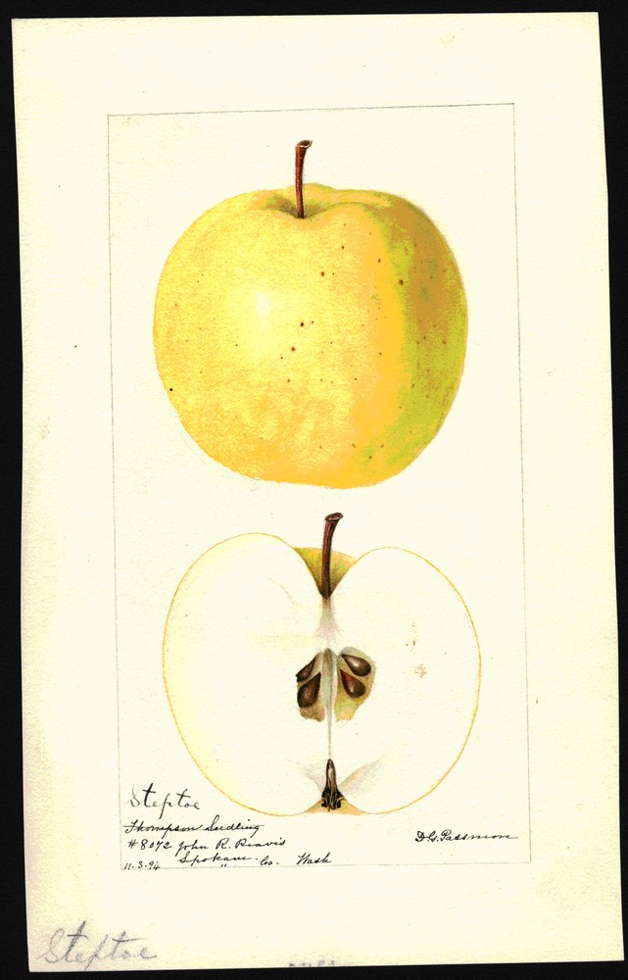
Steptoe
The Steptoe apple was initially introduced by a man living just north of Pullman, WA
Steptoe was raised from seed by John Thomson, Whitman County, Washington. Specimens were sent by John R. Reavis, Spokane, Washington, and received by the USDA on November 33, 1894. The apple has one painting in the USDA pomological watercolor collection. Described as large, round, with slight ribbing, the skin is pale yellow and considered of very good quality. It is an early winter variety. The site of the homestead was found, but all old apple trees had been removed. The re-discovered Steptoe apple was found approximately one hundred miles southwest of the original apple near Waitsburg, Washington, on the property of Kate and Eric Hockersmith.

