Photographic Detail of | Whip and Tongue Graft
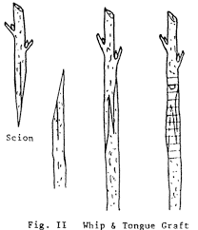  #1 Classic drawing of Whip and Tongue Graft | 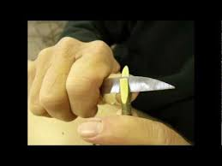  #2 Cutting the tongue on one of the whips
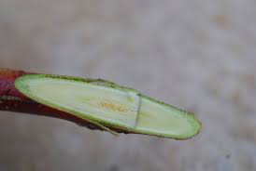  #3 Finished whip with tongue (note tongue starts about 1/3 way from outer end and goes rest of distance of slanted cut surface) | 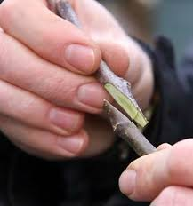  #4 Fitting the two whips together
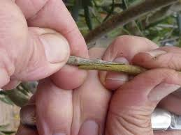  #5 Tongues engaged properly | 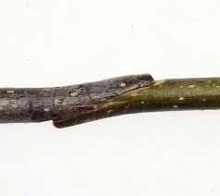  #6 Another view of the joint
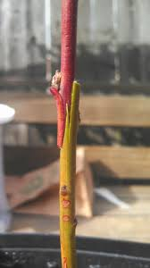  #7 And another view of the joint | 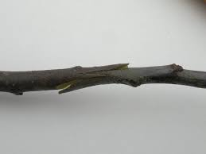  #8 And yet another view of the joint
