Cleft Graft Technique
Excerpt from Penn State Fruit Tree Propagation – Grafting and Budding:

Cleft Graft
Cleft drafting is the most commonly used method for topworking a relatively mature tree over to another variety. This system is used on stocks from 1 to 3 inches in diameter. The scion is prepared by making a tapering cut 1 to 2 inches long on each side (Figures 3a and 3b). The scion should be 3 to 4 inches long and about 3/8 to 1/2 inch in diameter.
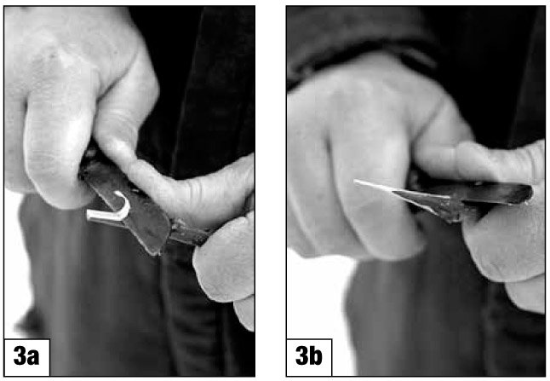
Figure 3. Tapering cut used to prepare the scion for a cleft graft. left graft.
The stock is cut off squarely (Figure 4a) and split vertically with a knife or cleft grafting tool to a depth of about 2 to 3 inches (Figures 4b and 4c). Keep the knife in position or insert a chisel to keep the split open and insert the scions (Figure 4d). The scion is placed so that its cambium layer and the cambium layer of the stock are in contact. All exposed surfaces are waxed or coated immediately. Usually, no wrapping is needed because the stock exerts sufficient pressure to hold the scions; however, wrapping the stock will ensure a tighter connection and less chance for the scion to be bumped out of the stock.
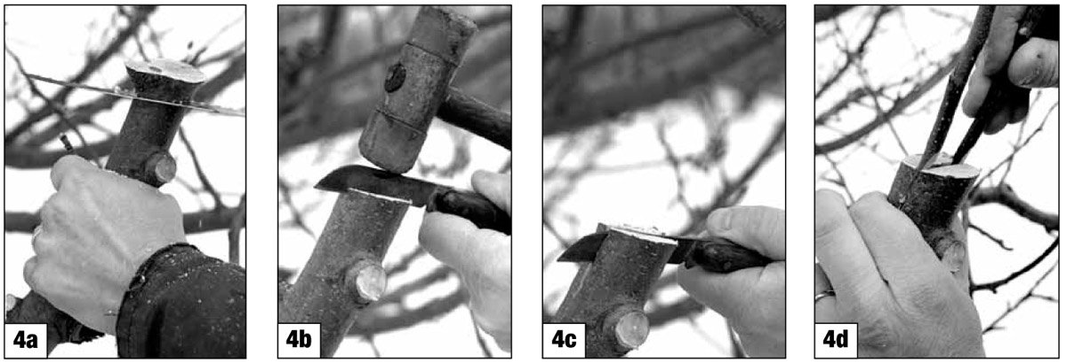
Figure 4. Splitting stock for a cleft graft.
After wrapping the scion and stock, paint the stock surface and the ends of the scions with a wound dressing or cover them with wax (Figures 5a and 5b).
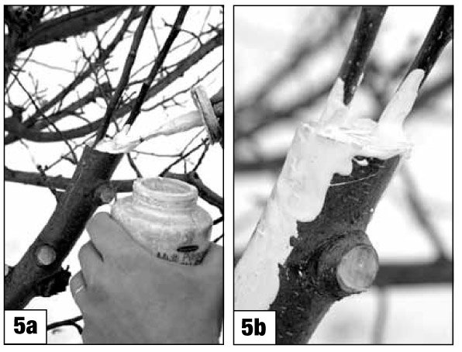
Figure 5. Covering scion and graft with wound dressing.
Once growth starts in the spring, the bark loosens, or slips. When this occurs, the bark and wood portions may not split evenly and clefting may not be satisfactory. You should then switch to either the bark or inlay type of graft.
After the scion starts to grow in the spring, a good idea is to cut off all of the wood from the old variety except one limb as a "nurse" limb (Figure 6). Later in the summer revisit the grafts to see how much growth is occurring. If excessive growth occurs or you are in a windy area, you may want to support the new scions. Tack a 1-inch piece of wood board below the union and fasten the new scion to the wood with ties.
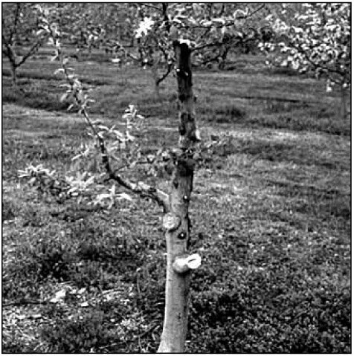
Figure 6. Nurse limb on recently grafted tree.

