Review of Plums at Chase Orchard in 2021
Picture of my Luisa taken in August, 2021
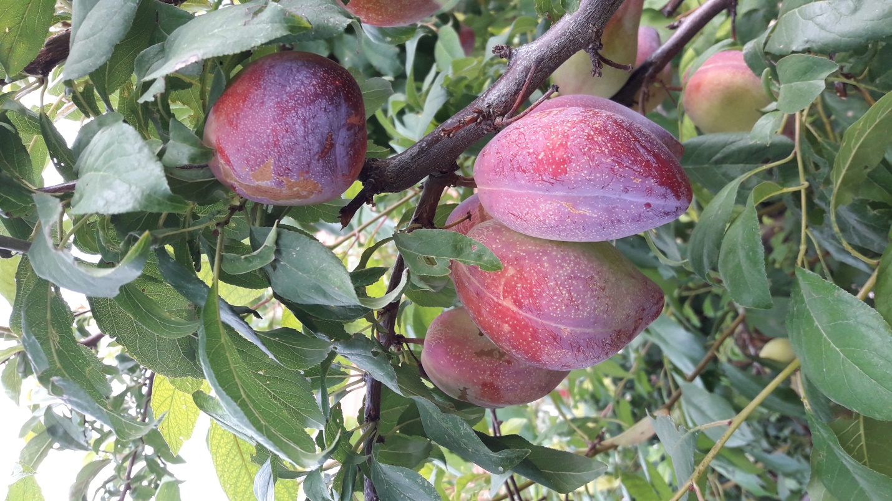
Below are late July and August Plums (these rankings are only against those ripening in July or August – not rankings overall among all plums – only one in top three here can complete well against September and October European plums)
Beauty – ok, but not impressive
De Montfort – very good (might be in top 5)
Duarte – very good (might be in top 5)
Early Golden – earliest, but not impressive
Early Laxton – also very early, but less impressive than Early Golden
Elma’s Special (Sanctus Hubertus) – outstanding (in top 5)
Honey Star – impressively sweet and juicy (in the top 5)
Luisa – outstanding (in top 3) They keep very well in refrigeration and can last into later October.
Methley – early and hangs for over a month.
Monsieur Hatif - outstanding (in top 3) It is a must have. I picked about 2 dozen of these in late August to refrigerate and ate them on November 8th. They had shrunk some and were almost jellied, but with good texture. They were great after over 2 months of refrigeration. Their pit would easily separate at this point and could be dried.
Obilnaja – pretty good (might be in top 5)
Opal - pretty good (could be in the top 6 and maybe top 5)
Oullins – outstanding (in top 5 and maybe in the top 3 for an early plum) It is a must have. They were picked and refrigerated in in late August and a few were still good on November 8th.
Parsons – very early and hangs well
Pipestone – ok, but not impressive
P. Domestica Rootstock – seem almost identical to Parsons (probably the origin of Parsons)
Santa Rosa – ok, but not impressive
Satsuma – ok, but not impressive
Shiro – ok, but not impressive other than appearance (they are a very beautiful yellow)
Toka – ok, but not impressive
Plums that ripen in September (rankings are against only plums ripening in September)
Bavey’s Gage (or Bavey’s Green Gage) – Superior strain of the Green Gage. In my top 5 for ripening in September. Keeps well in refrigerator (they were still in nice condition on November 8th.
Castleton – didn’t bear this year but it is in my top 5 for September. I would place this in my top 5 even though I think I have more than 5 in my top 5.
Gras Romanesc – absolutely great flavor, but so far has been a sparse bearer (although I have seen pictures of branches loaded with Gras Romansec in nursery descriptions) – definitely in top 3 for September ripening. Might be my #1 for September if I hand to rank order them, instead of just voting them in the top 3 or the top 5. Produced almost no new growth for scion wood.
Green Gage – excellent, but Bavey’s Gage is a better strain of the classic Green Gage. However, after storing in the refrigerator until November 8th it was hard to tell the difference and maybe after 6 weeks of refrigeration they may have actually been a little better than Bavey’s Gage.
Luisa – was in top 3 for August and because it ripens over time (not all at once) it is still producing outstanding fruit through to the 20th of September. Is in top 3 overall. Does not hang well, but if you check it daily you will be rewarded with some wonderful ripe plums that have just fallen on a bed of straw under the tree. Large, flavorful, freestone. So it is in my top 3 for September as well.
Mirabelle de Nancy – Mirabelles are those little tiny plums that are kind of a novelty (although they have good flavor and sweetness). I enjoy a few but plan to keep the tree small, just to have a few of these little novelty plums to sample each year.
Mt. Royal – very productive, good dried, excellent flavor. In my top 5 for September ripening. Refrigerates will.
Rosey Gage – great flavor and sweetness. In my top 5 for ripening in September.
Stanley – pretty good early version of Italian plum. Suppose to be good drying plum. It refrigerates well and was excellent at the November 8th tasting session. Could be in my top 5.
Superior – kind of a scruffy, poor producing tree, but with pretty good fruit. Wonder about the name, if that was a joke? Jury is still out on this one.
Victory – has to be in top 3 for September (comes on the very last week of September) and maybe top 3 overall. Huge plum with huge crops every year. Great flavor. Tends to ripen all at once but hangs well. It should be able to make in refrigeration all the way to Thanksgiving (was excellent at the November 8th tasting session. Is a freestone and I serve it in halves like I do the Luisa, another freestone. Because it bears heavily I haven’t had much scion wood available from it.
Yakima – very large plum with great flavor. In my top 5 for September.
Plums that ripen in October and early November (rankings are only against plums ripening in October or November)
Coe’s Golden Drop – large beautiful yellow plum ripens very late in October here. In my top 5 for October.
Empress – very large and very productive, but somewhat bland (although highly regarded in reviews)
Italian – I’m not a fan of Italian because there are many other Italian-style plums that surpass it.
Moyer – among best of the Italian-style plums. Better flavor and sweetness than the Italian. In my top 5 for October.
President – very large and very late (end of October, first of November) with excellent flavor and sweetness. In the top 3 for October-November. Will easily store in the refrigerator until Thanksgiving.
Prune d’Agen (also known at the Petite French Prune) – in my top 5 for October. Although slightly smaller than the Italian, they are sweeter and more flavorful.
Shropshire Damson – sour plum for making plum jam (very productive)
Sugar – you get better flavor and sweetness if you thin heavily
Valor – pretty good
Vision – pretty good
Note on when to refrigerate: It seems best to pick in their prime if you are going to refrigerate them.
Philosophy of selecting Plum varieties:
Because there are plums that ripen all the way from late July to early November, it seems reasonable to try to have varieties that ripen throughout the long plum season. If I could only have 6 plums I would pick two from each of the seasons. Which two? That is hard – I would probably change that to three per season (early, mid, and late), but would still have a problem that restriction.

Rootstocks for Plums:
St Julian A:
- precocious
- productive
- controls at 6 to 8 feet high for pedestrian orchard (no ladders)
- can also be used for apricots and peaches

Krymsk 1:
- precocious
- productive
- controls at 6 to 8 feet high for pedestrian orchard (no ladders)

St. Julian A and Krymsk 1 are my first choice and could be planted with 8 foot spacing if you choose. Marianna and Myro are also good and will require 10 to 12 food spacing.

Marianna GF8-1 and Marianna 2624
- not as suckering as Myrobalan
- good vigor but probably a little more size controlling than Myrobalan
- very widely used plum rootstock

Myrobalan
- suckering observed (sometimes a lot)
- good vigor (will need more pruning than St. Julian A or Krymsk 1)
- most widely used plum rootstock

Krymsk 86
- gives you a vigorous tree about the size of Marianna and Myrobalan
- should have less tendency to sucker than for Marianna or Myrobalan

Prunus Americana (American wild plum)
- used with Japanese plums and interspecifics
- expect some suckers

Prunus Domestica (wild plum from Europe)
- used for European plums
- expect a lot of suckers

Peach
- compatible with plum, apricot, almond, and peach

